# **Features**

## Completed in MVP

* Clear and simple language
* Clean and minimalist design since there will be diagrams etc
* Responsiveness
* List/ show the five (5) stages of the design thinking process: Empathize, Define, Ideate, Prototype, Test
* For one of the five (5) design thinking stages provide
  + Concise one-line description of what the Define stage accomplishes
  + Brief description explaining the role of the Define stage in the overall process, activities undertaken, techniques used and any deliverables produced.
  + List techniques used
  + Provide an example of a technique/ stage deliverable from successfully completed school project.
* Project example

## Required to complete project

* Completion of other stages
* Additional project example
* Theme modification, including logo, typography, colour, image formatting
* Accessibility features, including image optimisation, image captions and alt tags
* Search Engine Optimization

Optional Features

* Form for Feedback or contact information
* Exercises

# **UX and QA Testing**

## Test Plans

The following set of test plans was developed to ensure that the product solves the problem as specified in the Define stage.

|  |  |  |  |
| --- | --- | --- | --- |
| **Navigation** | | | |
| Test Area | Specific Test | Passed Y/N | Comments |
| Do all menu links work on all top-level pages | Home |  |  |
|  | Ideate |  |  |
|  | Prototype |  |  |
|  | Test |  |  |
|  | Projects |  |  |
|  | Test |  |  |
|  | Projects |  |  |
| Do all links under techniques sections go to a new page, Empathy Maps on Empathize Page works? | Home |  |  |
|  | Empathize |  |  |
|  | Ideate |  |  |
|  | Prototype |  |  |
|  | Test |  |  |
|  | Projects |  |  |
|  | Test |  |  |
|  | Projects |  |  |

|  |  |  |  |
| --- | --- | --- | --- |
| **Functionality** | | | |
| Test Area | Specific Test | Passed Y/N | Comments |
| Link states | Are all link hover states consistent? |  |  |
| Forms? |  |  |  |

|  |  |  |  |
| --- | --- | --- | --- |
| **Content** | | | |
| Test Area | Specific Test | Passed Y/N | Comments |
| Accuracy | Is content free of grammatical errors? |  |  |
|  | Is content free of spelling errors? |  |  |
| Formatting | Is content properly formatted so that there is clear hierarchy? |  |  |
|  | Is image placement contextually correct? |  |  |
| Language | Is content clear and concise |  |  |
|  | Is jargon used appropriately, not over-used and explained when it is used? |  |  |
|  | Are section headings and menu labels descriptive of what they contain? |  |  |

|  |  |  |  |
| --- | --- | --- | --- |
| **Consistency** | | | |
| Test Area | Specific Test | Passed Y/N | Comments |
| Page Layout | Do pages for each Design Thinking Stage have a similar layout? |  |  |
| Brand | Are brand colours or site colours used consistently? |  |  |
|  |  |  |  |

|  |  |  |  |
| --- | --- | --- | --- |
| **Accessibility** | | | |
| Test Area | Specific Test | Passed Y/N | Comments |
| Content | Is text in body left aligned? |  |  |
|  | Is body text appropriately sized and has good contrast? |  |  |
|  | Is content properly formatted so that there is clear hierarchy? |  |  |
|  | Is jargon used appropriately, not over-used and explained when it is used? |  |  |
| Images | Are images optimized for loading? |  |  |
|  | Do all images have captions? |  |  |
|  | Do non-decorative images have descriptive alt tags? |  |  |
|  | Are images appropriately sized? |  |  |
| Forms | Form fields have appropriate labels, that are clearly associated with them |  |  |
|  | Are related fields grouped? |  |  |
|  | Are required fields are clearly marked |  |  |
|  | Are input error messages provided? |  |  |

|  |  |  |  |
| --- | --- | --- | --- |
| **Performance** | | | |
| Test Area | Specific Test | Passed Y/N | Comments |
| Speed Testing   ([Make the Web Faster  |  Google Developers](https://developers.google.com/speed)) | Does page load at 90% or higher? |  |  |
|  | Is content free of spelling errors? |  |  |
| Browser Testing | Browser 1 – MS Edge |  |  |
|  | Browser 2 – Google Chrome |  |  |
|  | Browser 3 - Safari |  |  |
| Responsiveness | 320px to 480px |  |  |
|  | 481px to 768px |  |  |
|  | 769px to 1024px |  |  |
|  | 1025px to 1200px |  |  |

## Usability Testing

Test Scenario 1: The user needs to generate ideas to solve the problem of students purchasing less from the cafeteria because of the long time it takes to purchase. The user needs to learn about some ideation techniques.

Expected User Flow

Test Scenario 2:

The user wants to learn about the stages of design thinking because they are uncertain about the order.

Test Scenario 3:

The user wants to learn how to create low-fidelity wireframes, while using their phone on the bus.

# Visual Design

## Mood board

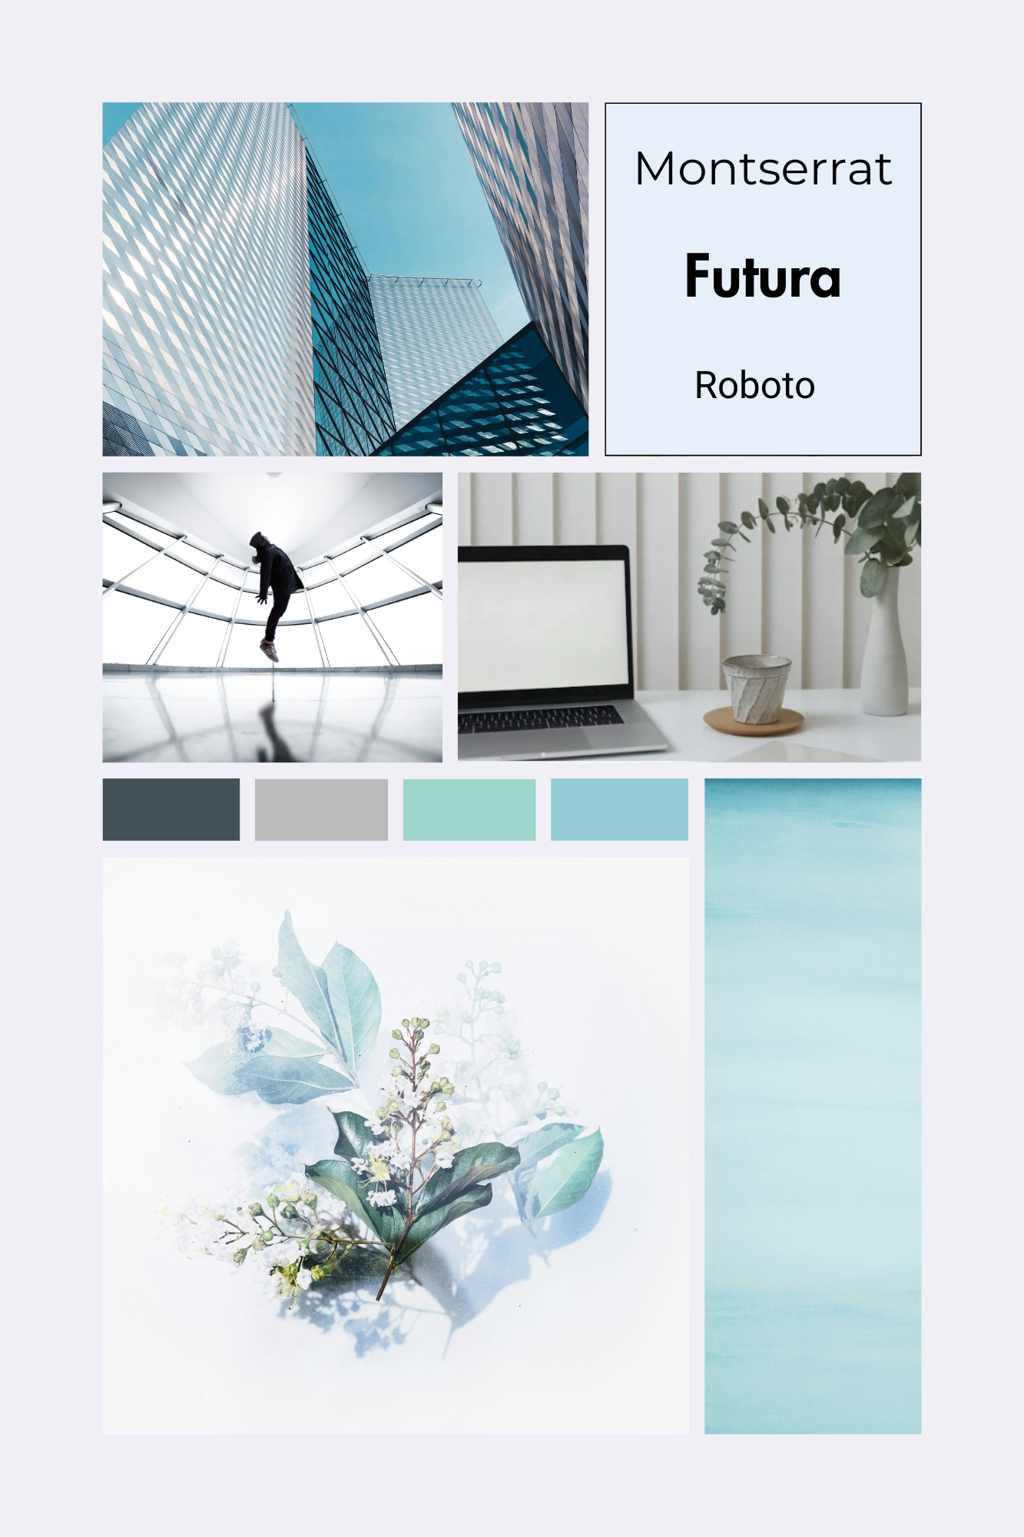

# Expected Targets

It is expected the following will be completed by the dates on the right

Site Design March 11

Usability Testing March 11

Completed site March 12

Revisions to site (feedback) March 26